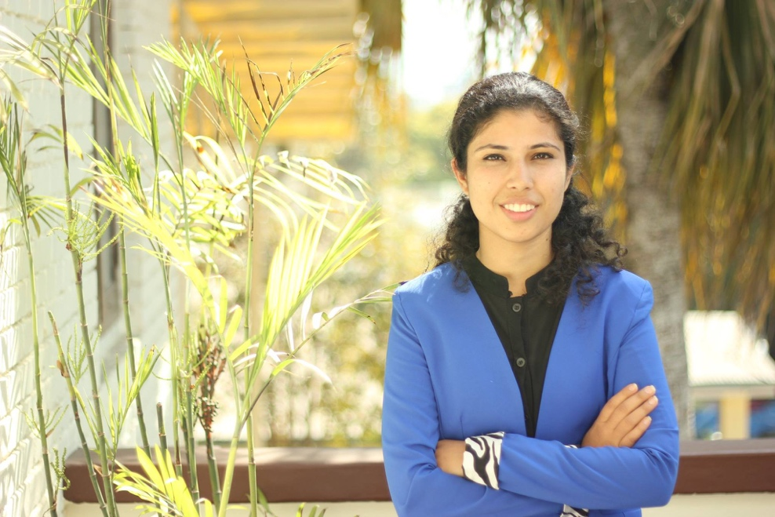

**AGNESHA DAHAL**

[agneshadahal95@gmail.com](mailto:agneshadahal95@gmail.com)| www.linkedin.com/in/agnesha-dahal/

Agnesha Dahal is a motivated Master's student of Wine Tourism Innovation who is building a strong foundation in wine marketing, wine tourism and wine making. With a Bachelor's degree in Business Administration and a Master's degree in Business Administration (Technology and Innovation), she has extensive experience in sales and marketing in various leadership roles. As a quick learner with excellent communication and interpersonal skills, Agnesha is eager to work closely with local partners to organize events and activities that provide an immersive and authentic experience for visitors while enhancing her own knowledge of the industry.

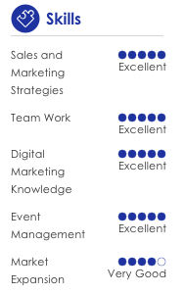



**ACADEMICS**

**Aug 2023- Present International Masters on Wine Tourism Innovation**

Universidade do Porto, Portugal

* Continuing education in Events Management, Wine Tourism Marketing and Communication, Portuguese Wine Region, Wine Tourism Behavior

**Jan 2023 –July 2023 International Masters on Wine Tourism Innovation**

Université de Bordeaux-Bordeaux, France

* Received Erasmus Mundus Scholarship
* Continuing education in French Wine Making Techniques, Wine Pairing and Wine Color, Digital Marketing Strategy, Video Making, Management of Wine Companies

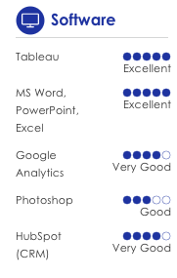**Sept 2022-Jan 2023 International Masters on Wine Tourism Innovation**

Universitat Rovira i Virgili- Tarragona, Spain

* Continuing education in Leisure Tourism, Sparkling Wine Making, Spanish D.O., Adaptation to Oenology, Spanish Wine Heritage, Winemaking Techniques

**2019-2021 Master in Business Administration- Technology and Innovation (4/4 CGPA)**

King’s College, Nepal (Affiliated to Westcliff University, USA)

* Received Merit Basis Scholarship
* Awarded Salutatorian
* Professional development completed in Resume writing, Data Analysis: SQL and Tableau, Excel
* Member of KAPPA ETA EPSILON HONOR SOCIETY

**2013- 2017 Bachelors in Business Administration (3.76/4)**

Kathmandu University School of Management, Nepal

* Advertisement and Promotion, Employee Training, and Project Management
* Dean's List 2013-2017
* 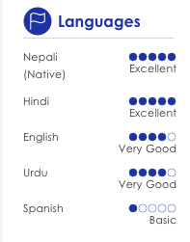Member of Social Club, Placement Cell, Drama Club, Editorial Club



**WORK EXPERIENCE**

**March 2021- Jan 2022 Nepal PayTime Pvt. Ltd.**

*Sales and Marketing Head*

* Led business development team of 3 to increase the merchant base
* Led sales and marketing team of 2 to enhance customer base and increase the visibility among customers
* Organized marketing campaigns and events to increase the awareness of the company
* Established strong merchant base of 100 merchants within 6 months

**Jan 2020- April 2020 WeTravel Inc., USA**

*Regional Sales Manager- South Asia*

* Handled all sales operations within South Asia region
* Opened 10 accounts within first month
* Awarded as sales person to open account and start transaction in shortest interval in company history

**July 2019- Jan 2020** **Oravel Stays, Singapore Pte. Ltd.**

*Deputy MMCEO-Senior sales manager*

* Led team of 10 people across Nepal
* Provided training to 20 people in sales team
* Best sales team in the 4th quarter of 2019

**Sept 2018- July 2019 Oravel Stays, Singapore Pte. Ltd.**

*Demand Manager- Sales*

* Opened 60 new account for continuous sales deal
* Achieved continuous target for 10 out of 11 months, achieved total room revenue of 9 millions in 11 months
* Received best sales performance award consecutively for 3 quarters, received employee of the quarter 4, Oyopreneur (who can excel in all departments) award for quarter 4

**Nov 2016- Jan 2018** **Biruwa Advisors Pvt. Ltd.**

*Business Assistant*

* Organized 10 events related to promotion of entrepreneurship in Nepal, including 'Last Thursdays with an Entrepreneur', 'Udhyami Bhetghat', and ‘Breakfast at Biruwa'
* Conducted 50 mentorship sessions, 4 market research, and assisted in preparing proposals and comprehensive business plans for startups and established businesses
* Successfully identified and followed up with 4 potential leads and contributed in business development activities
* Content writing for the company’s newsletter and blogs



**EDUCATIONAL EXPERIENCE**

**Aug 2023-Sept 2023 Menti Wines**

*Winemaking Intern*

* Participated in grape harvesting and assisted main winemaker in wine production and cellar management
* Collaborated with the winemaking team to maintain high-quality wine production

**June 2023- July 2023 Vintrail**

*Wine Tourism- Business Development B2B*

* Research emerging wine tourism destination in Asia and Scandinavia and conduct feasibility research
* Build database for wine bar and develop new product category
* Contact prospects clients for business development
* Assist Marketing team for content creation to expand the market category



**VOLUNTEER EXPERIENCE**

**April 2021- Present Federation of Nepalese Chamber of Commerce & Industry**

*Committee Member- ICT development committee*

* Plan and manage budget work in financial management subcommittee for the development of IT field

**Nov 2016-Apr 2021 Entrepreneurs for Nepal**

*Moderator*

* Managed largest entrepreneurship related group with more than 125,000 members
* Filter around 50 entrepreneurship related posts and 200 members on average on a daily basis to help promote entrepreneurship culture in Nepal

**May 2018-July 2018 Snowyak Foundation**

*Local Co-ordinator (Intern)*

* Organized fundraising events like Dance for Dolpa, Raft for Dolpa 2
* Supported in internal operations of the organization and communication with Snowyak fellows

**April 2018** **Local fellow (Impact Travel)**

* Built a school library, conducted teachers training with the help of foreign volunteers
* Managed the team of 18 Nepali and foreign volunteers

**Jan 2018-Feb 2018 Higher Institutions and Secondary Schools' Association Nepal (HISSAN)**

*Organizer*

* Organized two days international conference on “Quality Education in Federal Nepal”, Kathmandu
* Organized different thematic discussion which helped researcher scholars and policy makers to discuss on current situation of education in Nepal and helped in designing future strategies to address the need of Nepal in global context
* Lead the team of 20 volunteers and 350 participants to make the conference successful

**July 2014** **Local Development Volunteer Program**

* Involved in pilot project of Helambhu Education & Livelihood Project (Mondo Challenge Foundation Nepal)
* Taught English, maths and computer courses to underprivileged children of Shree Satkanyamati Lower Secondary School Involved in educational and other recreational activities with students

**Sept 2013** **Disable Human Right Center (DHRC)**

* Involved in Disabled Peoples’ Advocacy (DPAC) Project to advocate for the rights of property for disabled people



**AWARDS AND CERTIFICATES**

**Dec 2020** Winner of UN Women Using Gender Data Contest

**Dec 2019** Best in Sales, Oyopreneur, Employee of the Quarter

**Sep 2019** Best in Sales (Quarter 2)

**Jun 2018** Won University of Otago Business School Champion Peer-Leader Award with prize money of NZ$1000

**Sep 2016** 3rd Position in Ace Spectrum, National Management Competition

**Jun 2016** University of Otago Business School Highly Commended Journal Award

**Aug 2016** Top 10 best ideas in Idea Hunt, for the idea “Samajik Bazaar- *A Social Supermarket”*

**Sep 2015** 2nd Position in ESPIRIT, International Undergraduate Management Competition, Christ University

**Jun 2015** Commitment Award, Global Enterprise Experience



**REFERENCE**

Available on request